The Entity-Relationship (E-R) diagram is used to illustrate the logical structure of the database. It shows the main entities, their attributes, and the relationships between them. This diagram helps in understanding how data is organized and how different tables are connected in the system.
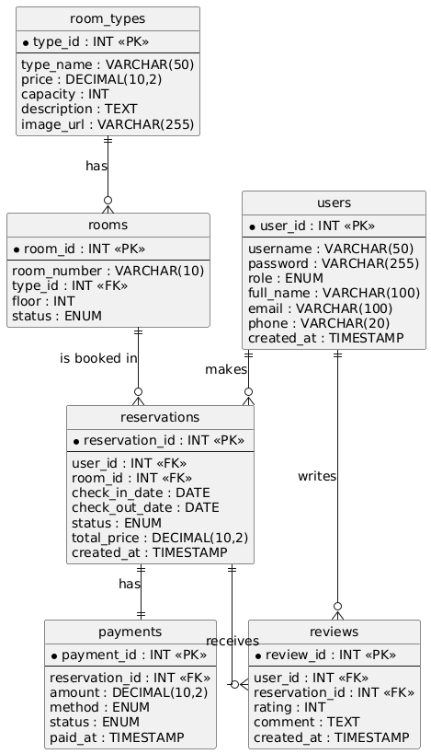
Figure 4 E-R Diagram of the Hotel Reservation Management System
As shown in Figure 4, the database consists of six main entities: users, room_types, rooms, reservations, payments, and reviews. A user (Guest) can make multiple reservations, and each reservation is linked to one room and one user. A room belongs to one room type, and one room type can have multiple rooms. Each reservation has exactly one payment record, and a reservation can receive reviews from users. These relationships ensure that the data is consistent and that the system can efficiently track reservations, payments, and customer feedback.

Table 1 Database Table Structure of users
Field | Type | Key | Description
user_id | INT | PK | User ID
username | VARCHAR(50) |  | Login username
password | VARCHAR(255) |  | Encrypted password
role | ENUM |  | GUEST, RECEPTIONIST, ADMIN
full_name | VARCHAR(100) |  | Full name
email | VARCHAR(100) |  | Email address
phone | VARCHAR(20) |  | Phone number
created_at | TIMESTAMP |  | Account creation time

Table 2 Database Table Structure of room_types
Field | Type | Key | Description
type_id | INT | PK | Room Type ID
type_name | VARCHAR(50) |  | Type name (Single, Double, Suite)
price | DECIMAL(10,2) |  | Price per night
capacity | INT |  | Maximum number of guests
description | TEXT |  | Room description
image_url | VARCHAR(255) |  | Room image URL
Table 3 Database Table Structure of rooms
Field | Type | Key | Description
room_id | INT | PK | Room ID
room_number | VARCHAR(10) |  | Room number
type_id | INT | FK | Reference to room_types
floor | INT |  | Floor number
status | ENUM |  | AVAILABLE, OCCUPIED, CLEANING, MAINTENANCE
Table 4 Database Table Structure of reservations
Field | Type | Key | Description
reservation_id | INT | PK | Reservation ID
user_id | INT | FK | Reference to users
room_id | INT | FK | Reference to rooms
check_in_date | DATE |  | Check-in date
check_out_date | DATE |  | Check-out date
status | ENUM |  | PENDING, CONFIRMED, CHECKED_IN, CHECKED_OUT, CANCELLED
total_price | DECIMAL(10,2) |  | Total price
created_at | TIMESTAMP |  | Creation time
Table 5 Database Table Structure of payments
Field | Type | Key | Description
payment_id | INT | PK | Payment ID
reservation_id | INT | FK | Reference to reservations
amount | DECIMAL(10,2) |  | Payment amount
method | ENUM |  | CASH, CREDIT_CARD, BANK_TRANSFER, E_WALLET
status | ENUM |  | PENDING, PAID, REFUNDED
paid_at | TIMESTAMP |  | Payment time
Table 6 Database Table Structure of reviews
Field | Type | Key | Description
review_id | INT | PK | Review ID
user_id | INT | FK | Reference to users
reservation_id | INT | FK | Reference to reservations
rating | INT |  | Rating (1-5)
comment | TEXT |  | Customer comment
created_at | TIMESTAMP |  | Review time

